Writeup – Evan Reeves

Question 1: What is the most important method for collecting information about exoplanets?

This question is addressed by the two bar charts, which show that ‘transit’ is responsible for far more discoveries than any other research method. Transit refers to cases where an exoplanet passes in front of a star, creating a shadow. Without it, most exoplanets are completely invisible, even to a 95 megapixel camera like the Kepler telescope. Radial Velocity, the second most effective method, uses the principle of redshift/blueshift. While a star is moving closer to the observer, the light it emits shifts into the infrared spectrum. In other words, it appears more red. Exoplanets of a sufficiently large size can pull their host stars closer or farther from the observer, which is detectable in terms of the frequency of light. The first bar chart compares all research methods, while the second removes the most successful ones in order to make the others visible.

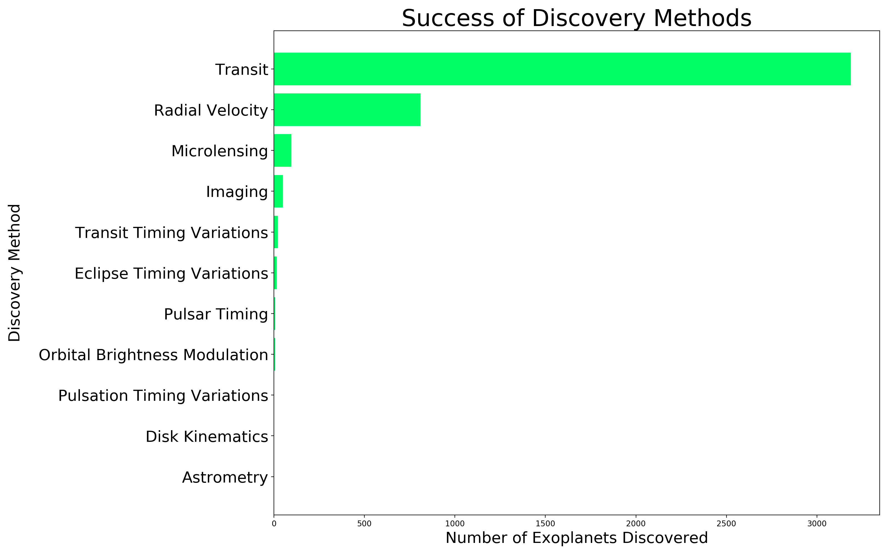

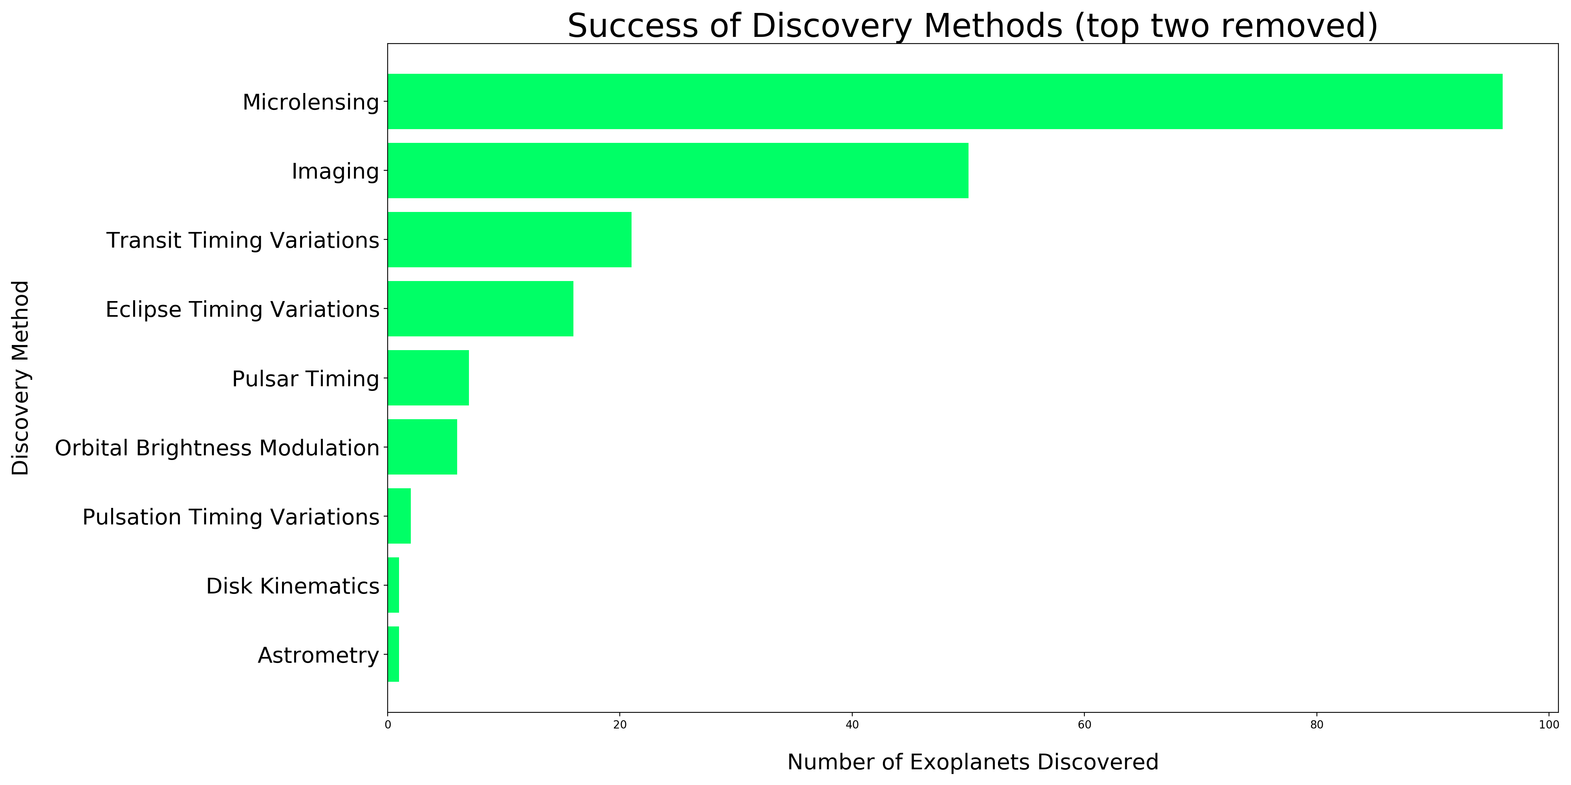

Question 2: What is the relationship between the characteristics of host stars and the planets that orbit them?

The data was not especially extensive, so there were not many columns I understood how to interpret. Leaving technical aspects of astronomy aside, I focused on stellar mass, the number of planets in orbit, and the average orbital period. I was hoping to see a linear correlation, but the results were extremely right-skewed. I was interested to see this because I assumed that larger stars would have more planets orbiting them, and that the orbits would be longer. It still seems that this could be true, given that the Transit observation method would be less effective at identifying an exoplanet far from its host star (because the shadow would be smaller) and the Radial Velocity method would not work (because planets distant from their host stars would not exert a significant pull on them).

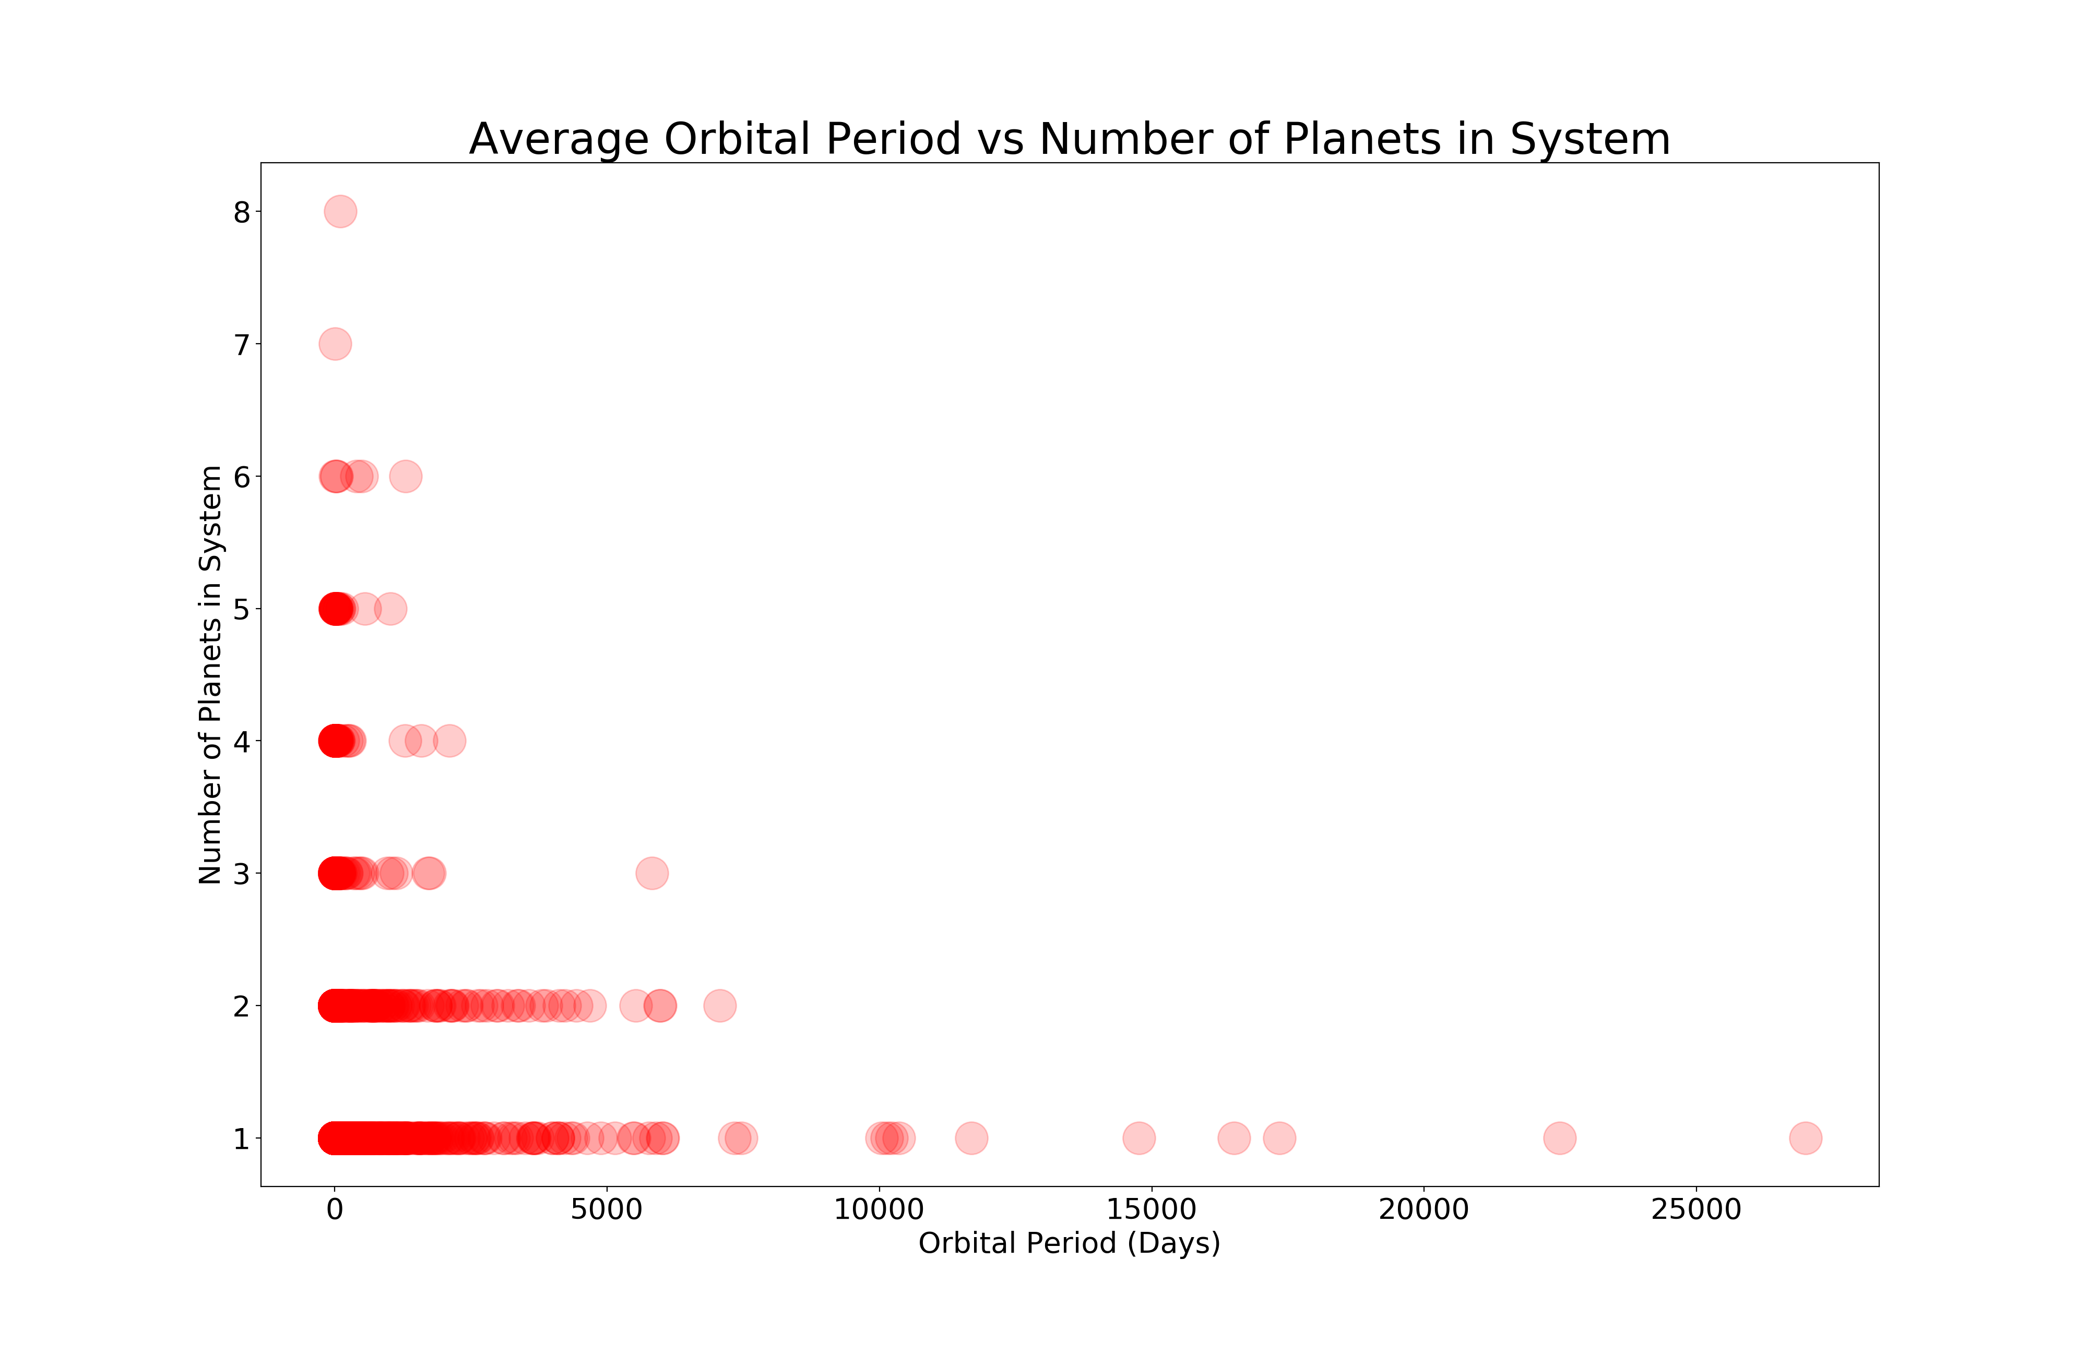

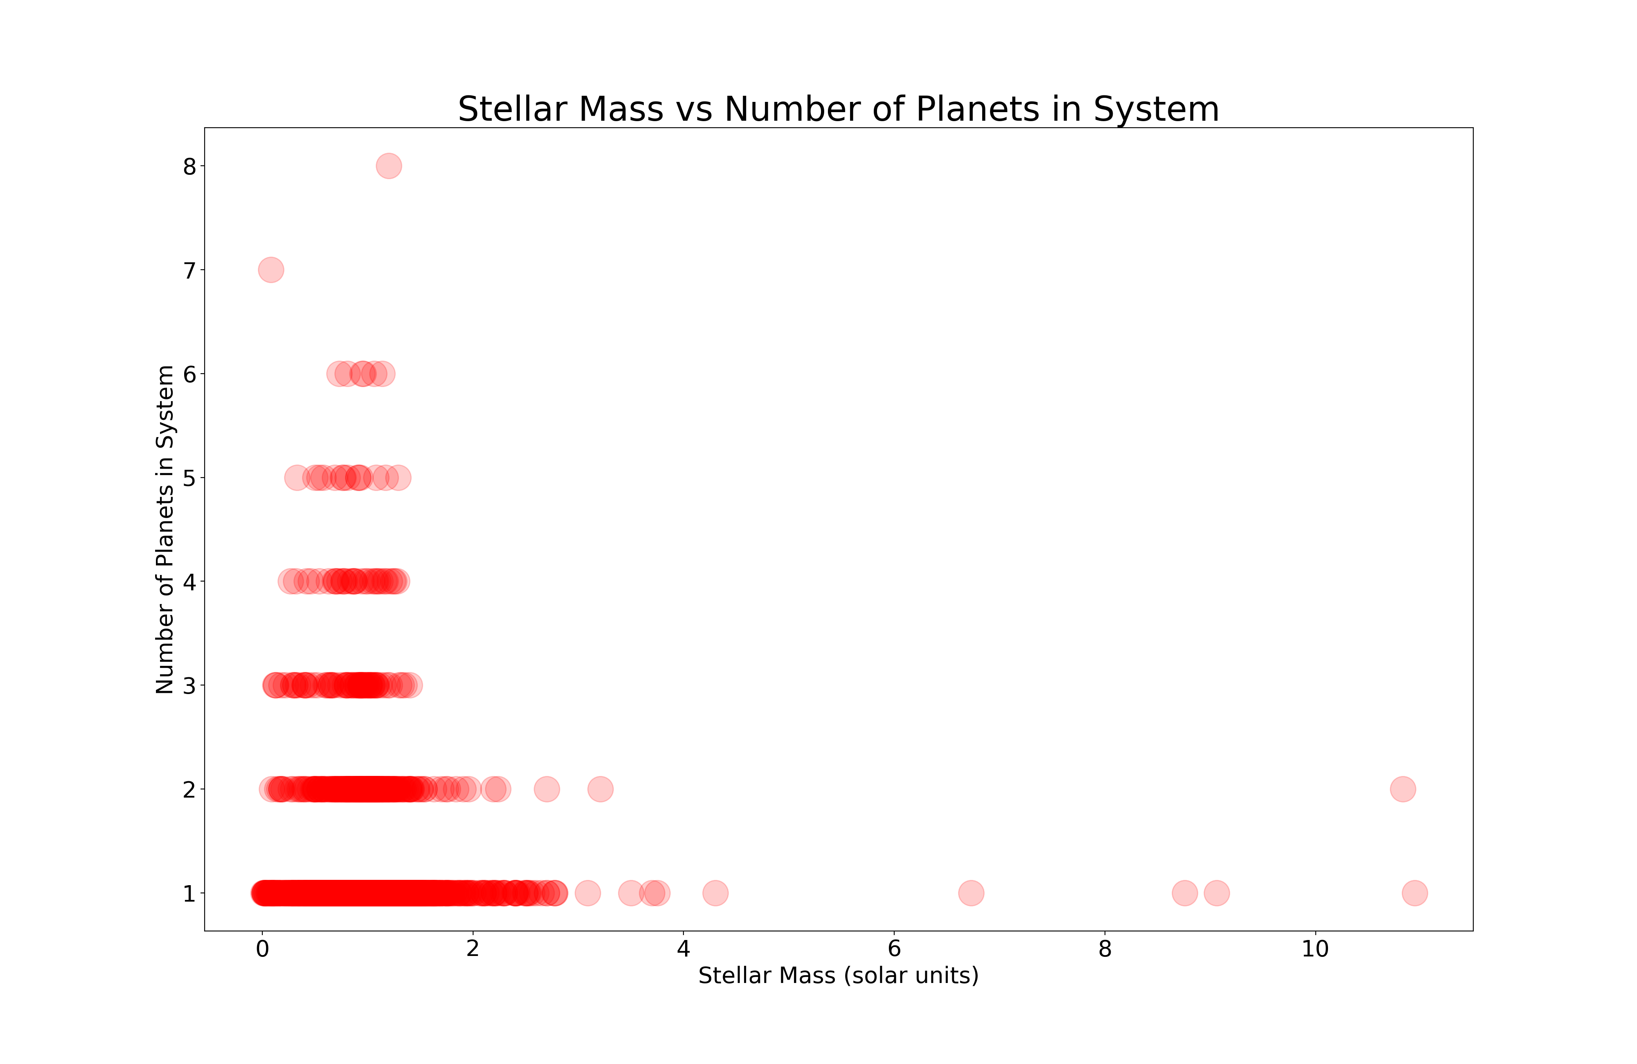

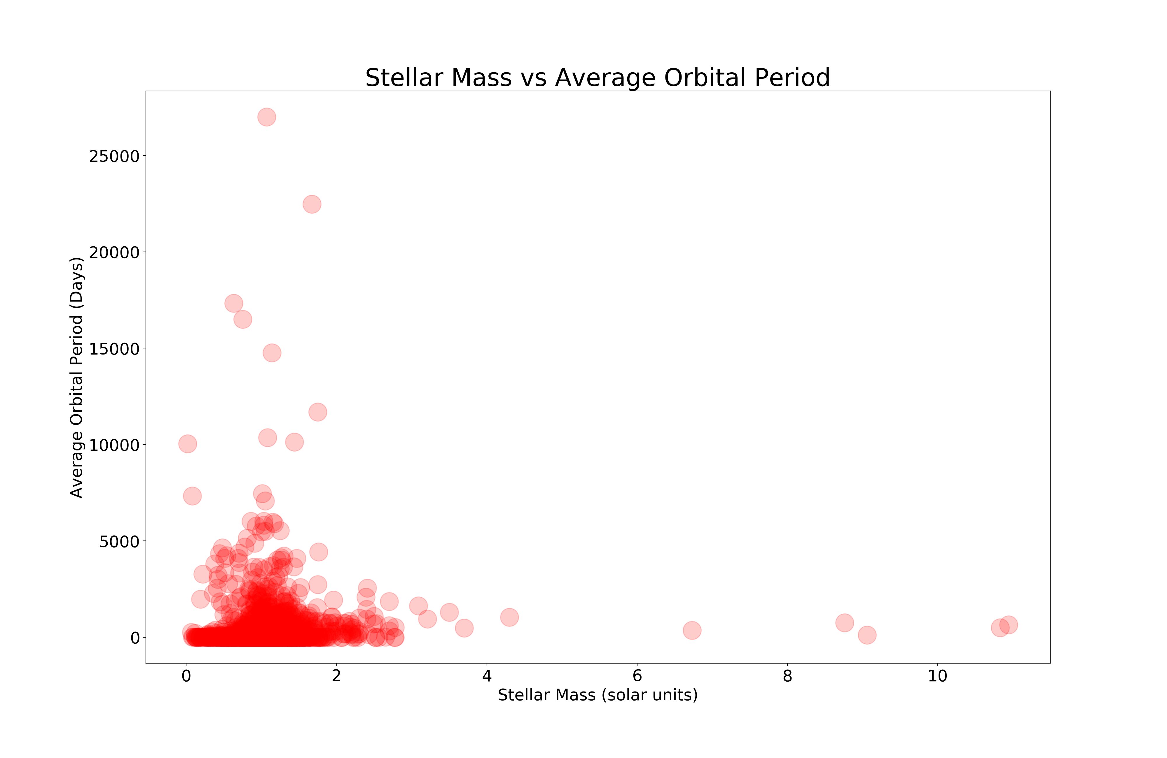

Question 3: Where are the exoplanets? How do they vary and how are they distributed?

This question is vague, but it is the most important. It is hard to visualize the location of any one exoplanet, and I have never been able to use telescopes. I wanted to know where the exoplanets are in general, and what they are like. I was expecting the data to include more information on surface features such as a description of each planet’s atmosphere, or a level of habitability. The only columns I was able to work with were distance, mass, and location (in terms of Right Ascension and Declination, the longitude and latitude of space). The most informative thing about this was the asymmetry in the graphs. I was not sure what I expected, but there is a distinctly uneven shape to the data. A study by Arnaud Cassan and colleagues predicted that there is most likely one exoplanet per star in the galaxy, which would be a total of 100,000,000,000 exoplanets. So far 4,281 have been discovered, in 3,163 systems. Some of the unevenness in the graphs is attributable to research methods. For example, all of these graphs show a dark cluster in the location of the Kepler field. In one of them, the shape of the satellite’s array is especially distinct. Another graph shows the same information, adjusting the size of each point to reflect the size of the planet, and making the color correspond to distance. There is not much of a relationship between size and distance, as demonstrated on another graph. I had expected larger planets to be farther away, but this is not the case.

The last two graphs are of the same data as they relate to planetary systems. Both are scatterplots of right ascension and declination coordinates, scaling the point size for different variables. One is scaled by the number of planets in the system, while the other is scaled by stellar mass and distance (color). I was not able to glean much information from these, but they are fairly interesting to look at.

